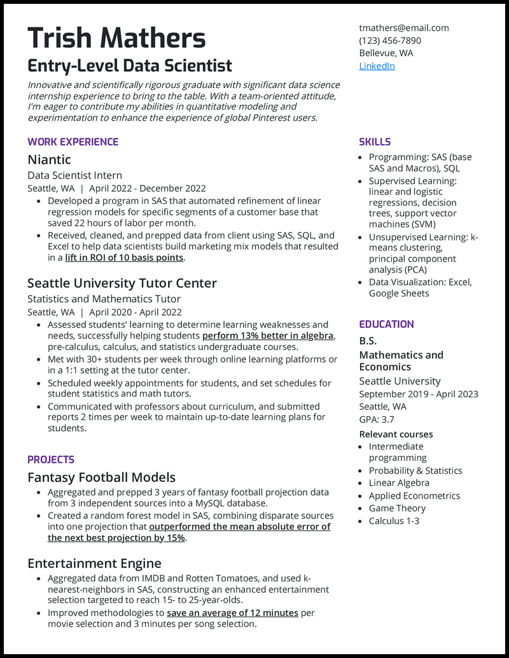
Trish Mathers
Entry-Level Data Scientist
Innovative and scientifically rigorous graduate with significant data science internship experience to bring to the table. With a team-oriented attitude, I'm eager to contribute my abilities in quantitative modeling and experimentation to enhance the experience of global Pinterest users.
WORK EXPERIENCE
Niantic
Data Scientist Intern
Seattle, WA | April 2022 - December 2022
• Developed a program in SAS that automated refinement of linear regression models for specific segments of a customer base that saved 22 hours of labor per month.
• Received, cleaned, and prepped data from client using SAS, SQL, and Excel to help data scientists build marketing mix models that resulted in a lift in ROI of 10 basis points.
Seattle University Tutor Center
Statistics and Mathematics Tutor
Seattle, WA | April 2020 - April 2022
• Assessed students' learning to determine learning weaknesses and needs, successfully helping students perform 13% better in algebra, pre-calculus, calculus, and statistics undergraduate courses.
• Met with 30+ students per week through online learning platforms or in a 1:1 setting at the tutor center.
• Scheduled weekly appointments for students, and set schedules for student statistics and math tutors.
• Communicated with professors about curriculum, and submitted reports 2 times per week to maintain up-to-date learning plans for students.
PROJECTS
Fantasy Football Models
• Aggregated and prepped 3 years of fantasy football projection data from 3 independent sources into a MySQL database.
• Created a random forest model in SAS, combining disparate sources into one projection that outperformed the mean absolute error of the next best projection by 15%.
Entertainment Engine
• Aggregated data from IMDB and Rotten Tomatoes, and used k- nearest-neighbors in SAS, constructing an enhanced entertainment selection targeted to reach 15- to 25-year-olds.
• Improved methodologies to save an average of 12 minutes per movie selection and 3 minutes per song selection.
tmathers@email.com
(123) 456-7890 Bellevue, WA LinkedIn
SKILLS
• Programming: SAS (base SAS and Macros), SQL • Supervised Learning: linear and logistic regressions, decision trees, support vector machines (SVM)
• Unsupervised Learning: k- means clustering, principal component analysis (PCA)
• Data Visualization: Excel, Google Sheets
EDUCATION
B.S.
Mathematics and Economics
Seattle University September 2019 - April 2023 Seattle, WA
GPA: 3.7
Relevant courses
• Intermediate programming
• Probability & Statistics • Linear Algebra • Applied Econometrics
Game Theory
• Calculus 1-3

